AI Patient Follow-Up Assistant — Architecture One-Pager
Sep 24, 2026 · @Muthuselvam M

Problem and solution
Hospitals miss follow-up communication after discharge, which leads to skipped appointments, missed medication changes and avoidable readmissions. The AI Patient Follow-Up Assistant closes that gap with three agents that summarize each patient's case, send personalized reminders, and escalate at-risk patients to care staff.
- Input: synthetic patient follow-up data (discharge notes, appointments, medications, patient responses) that learners generate.
- AI features: personalized reminders and follow-up summaries, grounded in patient records through RAG.
- Output: reminders to patients, summaries and escalation alerts to clinicians on a Streamlit dashboard.

Architecture
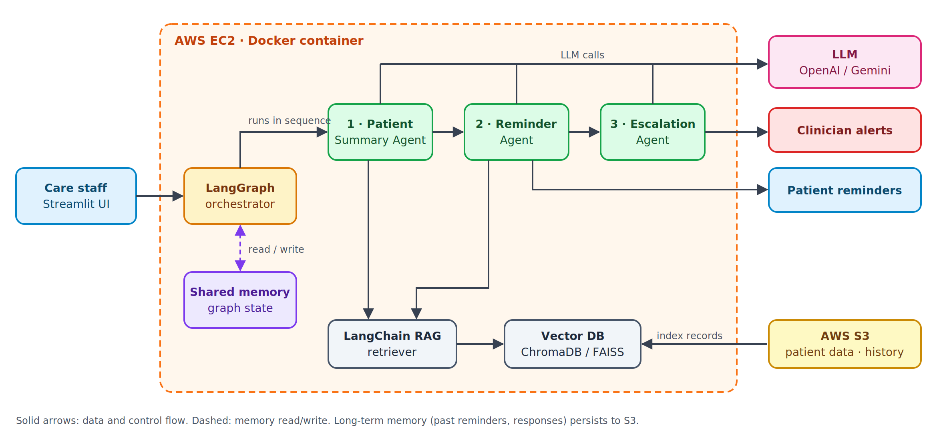
Requests flow left to right: the UI triggers the orchestrator, agents run in sequence over shared memory, and RAG grounds each LLM call in S3-backed patient records.

Agents and workflow
The three agents run as a sequential LangGraph pipeline; each reads and writes a shared state object, so later agents see earlier results and past interactions.

Step | Agent | Input | Output written to memory
1 | Patient Summary Agent | Patient record retrieved via RAG | Follow-up summary: diagnosis, meds, due visits, open tasks
2 | Reminder Agent | Summary + reminder history | Personalized reminder text, channel and send time
3 | Escalation Agent | Summary + reminder history + patient responses | Risk flag (none / watch / escalate) and clinician alert
Memory: short-term memory is the LangGraph state passed between steps in one run. Long-term memory (past reminders, responses, escalations per patient) is persisted to S3 and indexed in the vector store, so the next run can avoid duplicate reminders and spot repeated non-response.
Escalation rules (example): escalate when a patient misses two reminders in a row, reports a warning symptom, or misses a critical appointment.

Tech stack
Layer | Suggested tools | Role in this system
Agent framework | LangGraph / CrewAI | Sequential agent graph with shared state
LLM | OpenAI / Gemini | Summaries, reminder wording, risk reasoning
RAG | LangChain | Loaders, chunking, retrieval chains
Vector database | ChromaDB / FAISS | Embeddings of patient records and history
Frontend | Streamlit | Dashboard for staff: run follow-ups, review alerts
Deployment | AWS EC2 | Hosts app, agents and vector store
Storage | AWS S3 | Synthetic patient data, logs, long-term memory
Containerization | Docker (optional) | One image for app + agents, reproducible deploys

Deployment, data and guardrails
AWS deployment: one EC2 instance (e.g. t3.medium) runs a Docker container with Streamlit, the LangGraph agents and a local ChromaDB/FAISS index. An IAM role gives the instance read/write access to one S3 bucket; LLM API keys live in AWS Secrets Manager or environment variables, never in code. Streamlit is exposed on port 8501 behind a security group limited to known IPs.
Synthetic data: learners generate 50–200 fictional patients as JSON/CSV in S3, each with demographics, discharge summary, medications, appointments and a log of reminder responses. Include edge cases (non-responders, warning symptoms) to exercise the Escalation Agent.
Guardrails:
- Synthetic data only; no real patient information in prompts, logs or S3.
- Reminders avoid clinical advice; escalations always go to a human clinician.
- Every agent output is logged to S3 for review and evaluation.

